Nama : Sidna Muhammad Zen

NIM : 189090144

Kelas : 5B

**PRAKTIKUM 3**

1. Source Code

Matakuliah.php-> application/controller

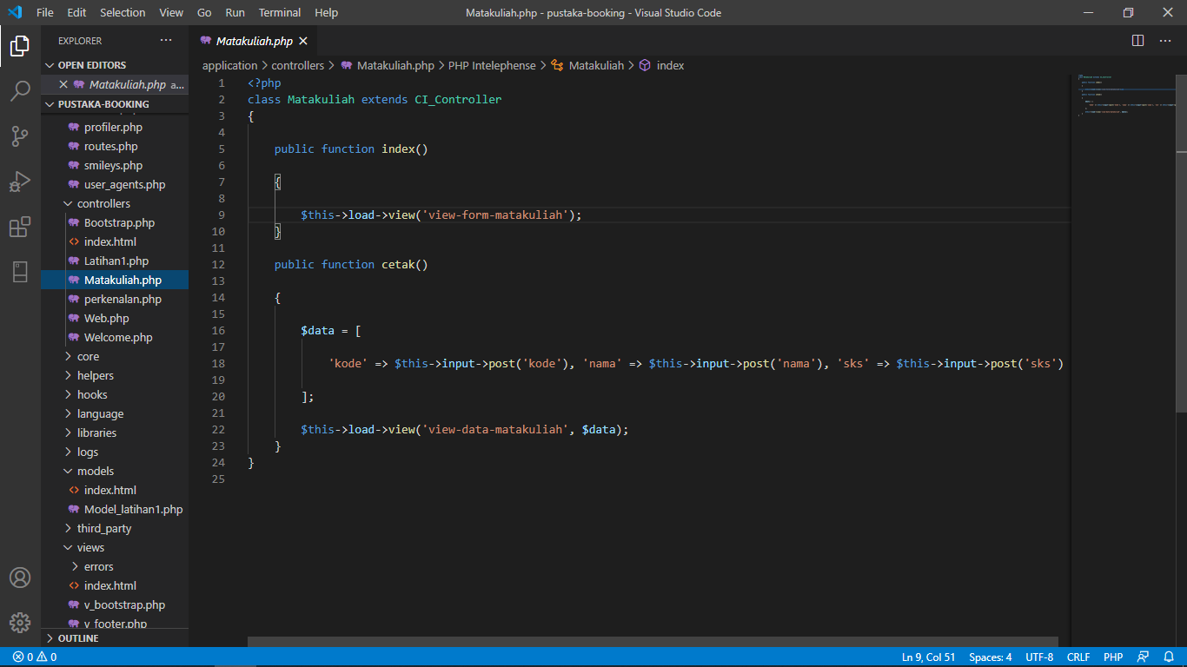

View-form-matakuliah.php->application/view

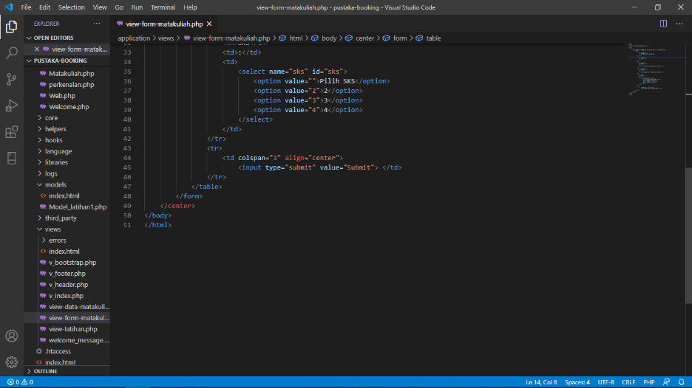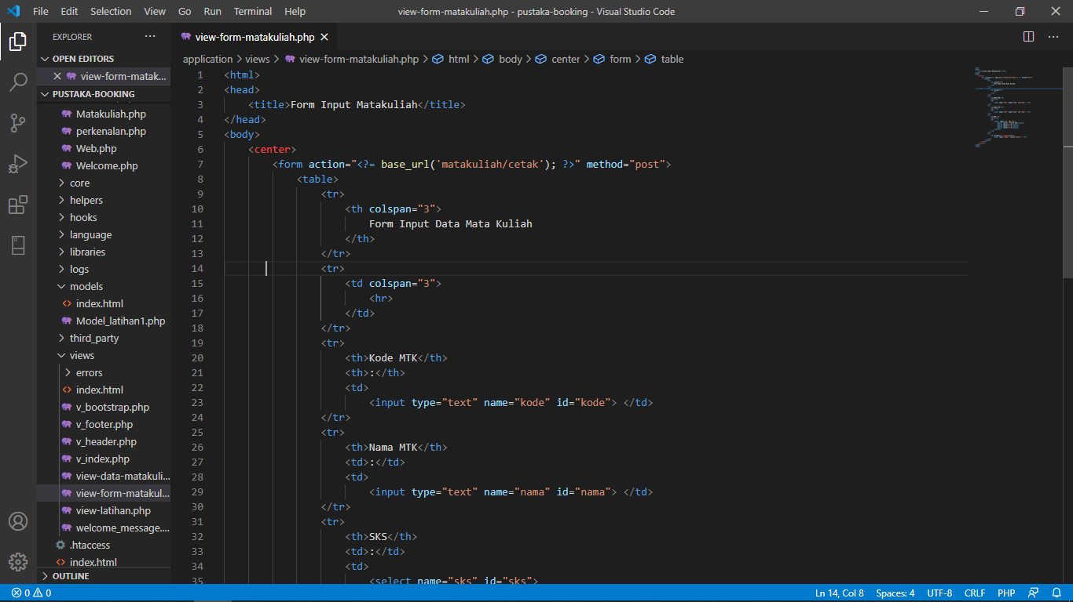

1. URL

[http://localhost/pustaka-booking/](http://localhost/pustaka-booking/Matakuliah)

1. Capture Hasil

